Europe’s fun sports and great sports people

LESSON PLAN

Module 15 “FOOTBALL IN EUROPE”

Topic: “European football champions”

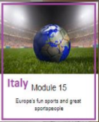

TEACHERS : Italian team

TIME: a year
RECIPIENTS: SECOND CLASSES SECONDARY SCHOOL I.C.ERODOTO
INVOLVED SUBJECTS: Geography, Physical Education ,L 1 and L 2,History.

Aims
The students will:
-Know great football players.
-Compare the various European and world competitions
Expected results
• -to observe the particularities of the different players
• -to describe the roles played by the different player

Teaching form
Lab activities

Teaching methods
Frontal, group and work in pairs, method of speech, demonstrative, method of research, works using textes and illustrative method

Materials
- Books, pictures, computer – presentations, posters, photos, brochures, markers, coloured pens or pencils, glue, scissors, board
- projector, screen
- speakers
- laptop or computer with the Internet connection
- tablets with QR scanners
- worksheets

Instructions
Stage 1: INTRODUCTION
Discussion about Italian and foreigner football players:
•Research about the origins of football
• Discussion about the difference between the various roles played in the field
• Identification of the most famous players in Italy and in Europe
• Identification of the major Italian and European competitions
https://it.m.wikipedia.org/wiki/Storia_del_calcio https://it.m.wikipedia.org/wiki/Coppe_calcistiche_europee
http://www.calcioefinanza.it/2017/03/06/migliori-calciatori-in-europa/
https://www.skuola.net/educazione-motoria-medie/sport
https://europa.eu/european-union/topics/sport_it

Stage 2: PRESENTATION
The best Italian and foreign players and the most important competitions.
.
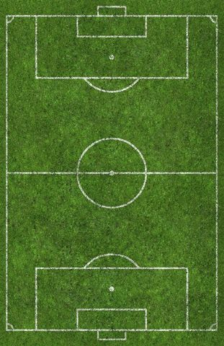
.
STAGE 3: GROUPWORK
a) Divide the classes into groups and make a card (name, surname, place of birth, role, team of origin, current team) of the player you want to adopt.
b) Appoint a group leader who will deliver the card after consulting all the components
c) The groups will be given a fixed time of five minutes to consult and report the answer

STAGE 4: CONSOLIDATION
In the end the students will produce a ranking of the most beloved players
Italian team

